4.Scenario: You are working on a project that involves analyzing the sales performance of a company over the past four quarters. The quarterly sales data is stored in a NumPy array named sales_data, where each element represents the sales amount for a specific quarter. Your task is to calculate the total sales for the year and determine the percentage increase in sales from the first quarter to the fourth quarter.

Question: Using NumPy arrays and arithmetic operations calculate the total sales for the year and determine the percentage increase in sales from the first quarter to the fourth quarter?

**Code:**

import pandas as pd

import numpy as np

# Step 1: Read the CSV file

df = pd.read_csv(r"C:\Users\vara prasad\Downloads\quarterly_sales.csv")

# Step 2: Convert the 'Sales' column into a NumPy array

sales_data = df['Sales'].to_numpy()

# Step 3: Calculate total sales for the year

total_sales = np.sum(sales_data)

# Step 4: Calculate the percentage increase from Q1 to Q4

percentage_increase = ((sales_data[3] - sales_data[0]) / sales_data[0]) * 100

# Step 5: Print the results

print(f"Total sales for the year: ${total_sales}")

print(f"Percentage increase from Q1 to Q4: {percentage_increase:.2f}%")

**Output:**

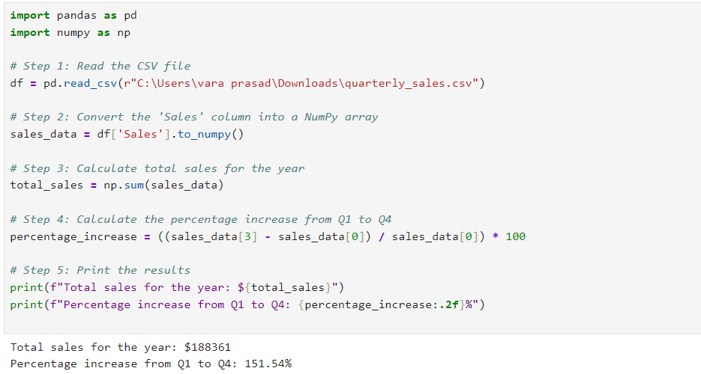

**Dataset:**

|  |  |
| --- | --- |
| Sales | Sales |
| Q1 | 25795 |
| Q2 | 10860 |
| Q3 | 86820 |
| Q4 | 64886 |